note note note: i have provided the exact texts so i suggest just ctrl f and search the key words para di kayo mahirapan, also refer on the pages :)) if there is something that needs to be change, chat sa gc so we could all be informed.

[step 1: project set-up]: copy pasting the cards (cards.txt)
created the file – did the requirement.

made a .txt file for cards (cards.txt) — edited its properties (1) copy output directory)) so from ‘do not copy’ naging copy always para kapag ni-run yung program, magrrun siya from separate output folder. Basically every time you run the program, visual studio automatically copies cards.txt into the bin/Debug/ folder where the program actually runs — so it can find and read it.

[step 2: project set-up]: creating Enums (Enums.cs)
i made another .cs file and named it Enums as instructed sa docs given by sir (pg 17 - pg 22)
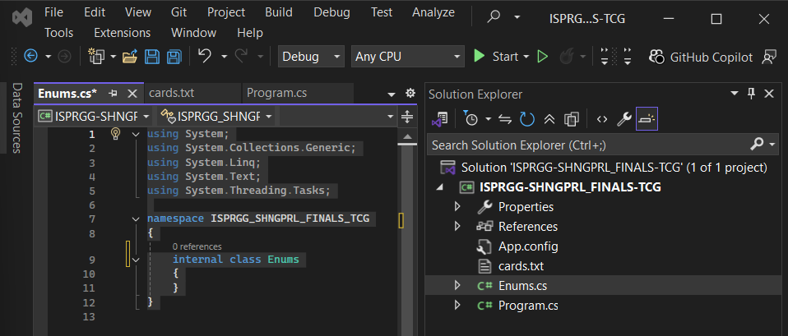
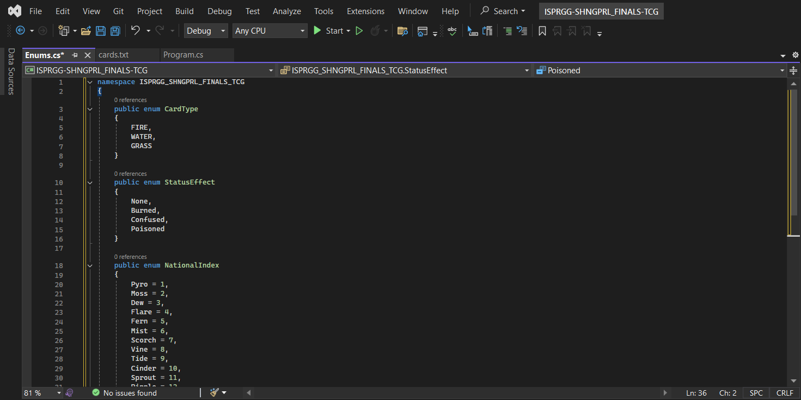
quickie note: during this, i learned that itll be the same procedure over and over for creating cs file. i got confused lang a bit when i created a .txt file but i explained how i did it sa baba nmn… tnx pu >_<

[step 3]: creating class cards (connecting the functions na pu)
please refer to pg 4 & pg 20 (class hierarchy and class skeleton (pang #7)). now we’re moving on to connect both card.txt & card.cs (upon my understanding). so the flow is cards.txt — FileLoader — Card objects — Game uses them.

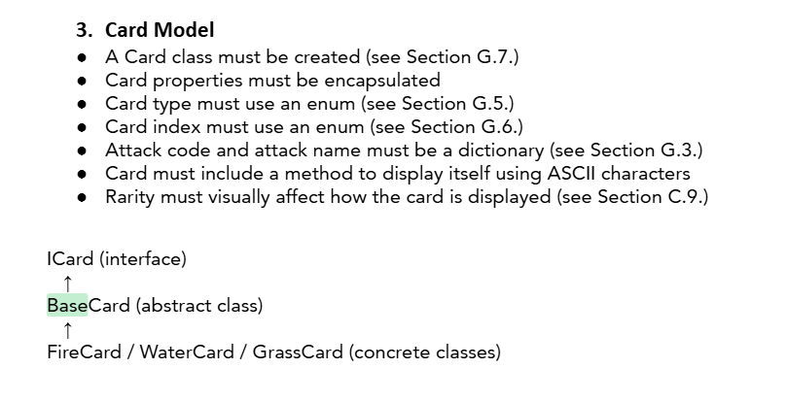
we also need to take into account that we needed to follow this format. note: the comments are included with the code, let’s delete it na lang once we finalized our output.
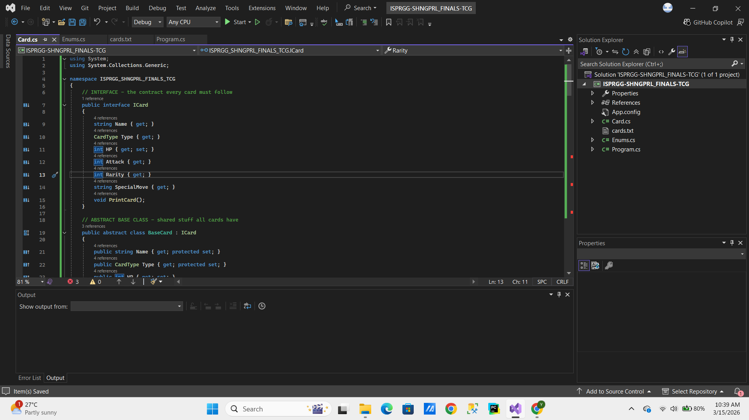
i’ve copied the skeleton code provided on the pages i’ve mentioned above. however, for the description naman ng cards; it’ll be seen pg 15 (e. student starter skeleton), i’m sure tama naman mga pinaglalagay ko sa code itself since i just copied yung pang num 3 e. student starter skeleton c#.

[step 4]: creating card print system (CardPrinter.cs)
please refer to pg 8-11 for num 9 card print system. ito na yung card display with diff borders w diff rarity level. note again: pls tell me if may mali ba sa code since medj madami ako times here nag error:)
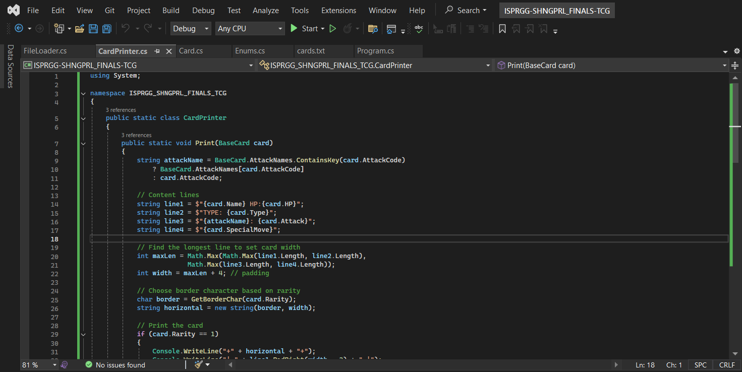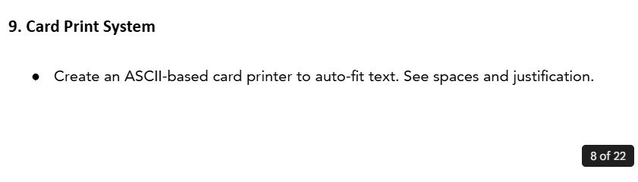[step 4]: creating card file loader (FileLoader.cs)
please refer to pg 21 of the docs — it reads each line of cards.txt, splits it by commas, and creates the right card type.
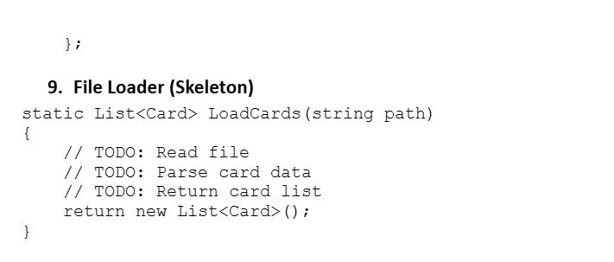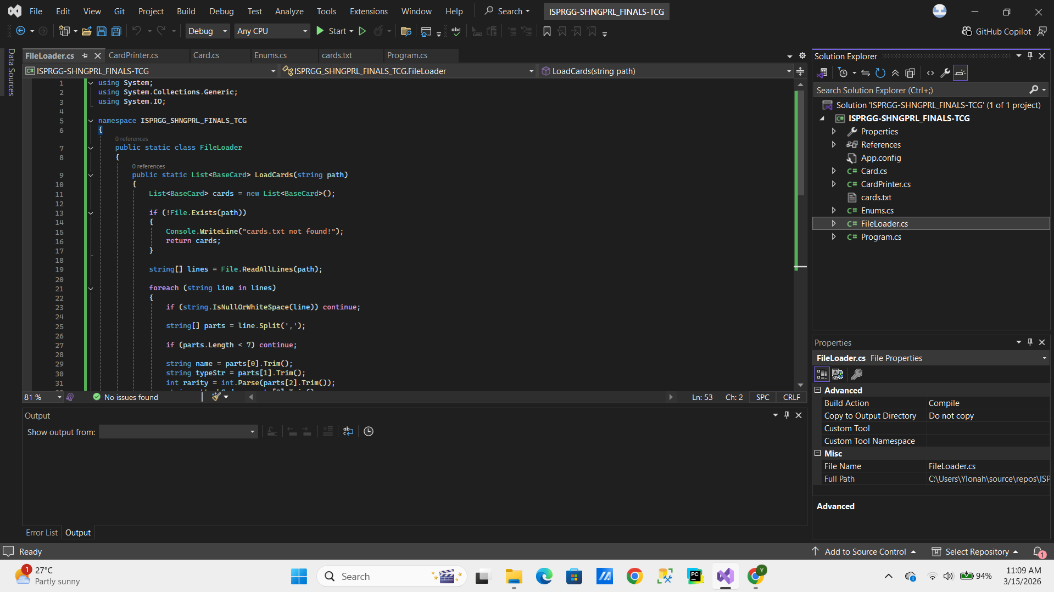
this func raw connects the cards.txt (which is the data/blueprint that defines each card) and card.cs

[step 5]: creating the main program (Program.cs)
please refer to pg 3-5 (C.1 Menu-Based Program, C.4 Card Pulling System, C.5 Card Binder System) and pg 18 (E.4 Program.cs Skeleton) and pg 21 (E.10 File Saver Reference).
this is the main controller of the whole game — it connects all the other files together. here's what each part does:
variables (top of class):
allCards — stores ALL cards loaded from cards.txt
pulledCards — stores cards the user has pulled
binderPullCount — tracks how many times each card was pulled
rng — random number generator for pulling cards
methods:
- Main() — loads cards, loads previous pulls, and shows the menu loop (pg 3, C.1)
- PullCards() — randomly pulls 5 cards, displays them with ASCII borders, updates binder, saves to pulls.txt (pg 5, C.4)
- DisplayBinder() — shows the 5x3 binder grid with pulled card names or index numbers (pg 5 & pg 12, C.5)
- SavePulls() / LoadPulls() — saves and loads pull data to/from pulls.txt so data persists even after exiting (pg 21, E.10)
note: pls tell me if may mali sa code since medj marami pang parts na need i-implement like battle mechanics and replay options
[addtl step]: ai card selection in Program.cs
please refer to pg 6 (C.7 AI Card Selection) ng docs.
shai made a diff approach for AI card selection — wherein she created a separate pull class with the StartBattle method. Yun lang, hindi siya applicable cuz if we’re basing sa specs, it says “"The AI must randomly select one card from the same card database." — basically, what it means is same card database ay yung buong allCards list na galing sa cards.txt — hindi lang yung mga na-pull ng player.
What i did instead to fix the issue:

- allCards = the full card database loaded from cards.txt
- rng.Next(allCards.Count) = randomly picks an index from 0 to 44 (45 cards total)
- the card at that random index becomes the AI's card. Also the approach does not duplicate the logic in another class

[step 6]: DisplayBinderSystem (Program.cs) + PrintWithCount (CardPrinter.cs)
please refer to pg 12 (C.10 Binder Print System) of the docs.
this step adds the ability for the user to view individual card details from the binder after pulling cards.
what we added:
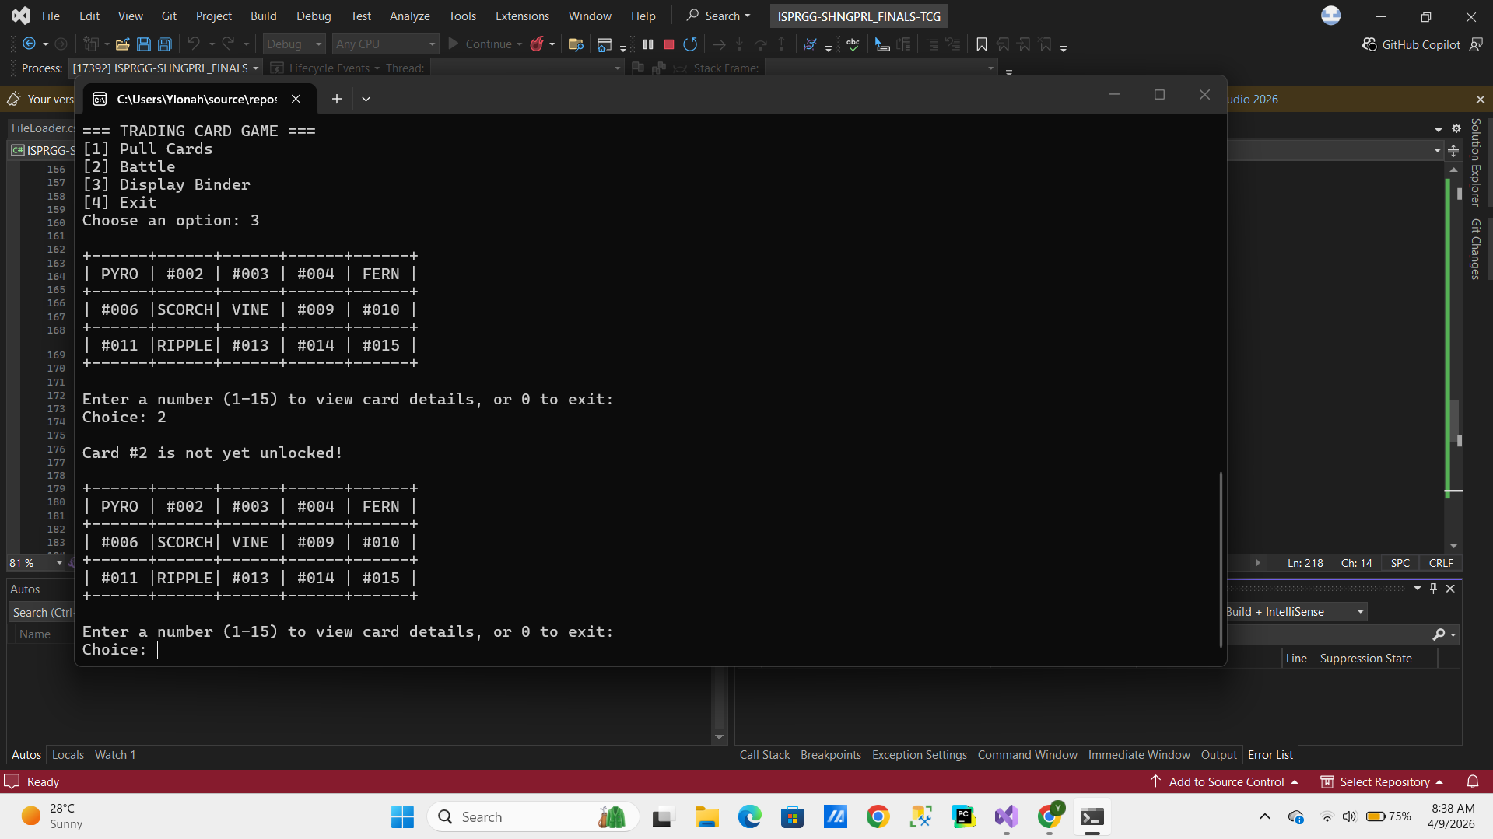
in Program.cs — added DisplayBinderSystem() method:
- shows the binder grid first
- prompts the user to enter a number 1-15 to view a card
- if the card is not yet pulled → shows "Card #X is not yet unlocked!"
- if the card has been pulled → shows the card details with pull count indicator
- user can keep viewing cards or enter 0 to exit the binder
- updated menu case "3" to call DisplayBinderSystem() instead of DisplayBinder()
in CardPrinter.cs — added PrintWithCount() method:
- 1 pull = normal card display
- 2-5 pulls = ++ / +++ / ++++ / +++++ added to the right of each line
- 6+ pulls = x6, x7, etc. shown on the top border
struggles encountered:
- PrintWithCount was not found at first kasi tinawag siya sa Program.cs bago pa nadagdag sa CardPrinter.cs → fixed by adding the method to CardPrinter.cs
- yung ++++ suffix hindi nag-aalign properly sa card border → fixed by adjusting the padding width
- yung x6 label positioning kailangan pang i-adjust para lumabas sa top border line

